Mauritius

## GNI per capita and development level

The data set shows the GNI per capita and development level of the country each year.

## # A tibble: 19 x 5  
## country iso3c date GNIperCapita devCategory   
## <chr> <chr> <dbl> <dbl> <chr>   
## 1 Mauritius MUS 1996 2988. Lower Middle Income  
## 2 Mauritius MUS 1998 2988. Lower Middle Income  
## 3 Mauritius MUS 2000 2988. Lower Middle Income  
## 4 Mauritius MUS 2002 1290. Lower Middle Income  
## 5 Mauritius MUS 2003 2988. Lower Middle Income  
## 6 Mauritius MUS 2004 2988. Lower Middle Income  
## 7 Mauritius MUS 2005 3850. Lower Middle Income  
## 8 Mauritius MUS 2006 6789. Upper Middle Income  
## 9 Mauritius MUS 2007 7283. Upper Middle Income  
## 10 Mauritius MUS 2008 7566. Upper Middle Income  
## 11 Mauritius MUS 2009 7715. Upper Middle Income  
## 12 Mauritius MUS 2010 7928. Upper Middle Income  
## 13 Mauritius MUS 2011 8164. Upper Middle Income  
## 14 Mauritius MUS 2012 8832. Upper Middle Income  
## 15 Mauritius MUS 2013 9417. Upper Middle Income  
## 16 Mauritius MUS 2014 9752. Upper Middle Income  
## 17 Mauritius MUS 2015 10136. Upper Middle Income  
## 18 Mauritius MUS 2016 10491. Upper Middle Income  
## 19 Mauritius MUS 2017 11016. Upper Middle Income

## GDP growth and economic growth classification

The data set shows the GDP growth and the ecomic growth classification of the country each year.

## # A tibble: 19 x 5  
## country iso3c date GDPannualGrowthRate GDPgrowthCategory4  
## <chr> <chr> <dbl> <dbl> <fct>   
## 1 Mauritius MUS 1996 5.59 fast growth   
## 2 Mauritius MUS 1998 6.07 fast growth   
## 3 Mauritius MUS 2000 8.20 fast growth   
## 4 Mauritius MUS 2002 1.61 slow growth   
## 5 Mauritius MUS 2003 5.93 fast growth   
## 6 Mauritius MUS 2004 4.33 moderate growth   
## 7 Mauritius MUS 2005 1.78 slow growth   
## 8 Mauritius MUS 2006 4.87 moderate growth   
## 9 Mauritius MUS 2007 5.73 fast growth   
## 10 Mauritius MUS 2008 5.39 moderate growth   
## 11 Mauritius MUS 2009 3.32 moderate growth   
## 12 Mauritius MUS 2010 4.38 moderate growth   
## 13 Mauritius MUS 2011 4.08 moderate growth   
## 14 Mauritius MUS 2012 3.50 moderate growth   
## 15 Mauritius MUS 2013 3.36 moderate growth   
## 16 Mauritius MUS 2014 3.74 moderate growth   
## 17 Mauritius MUS 2015 3.55 moderate growth   
## 18 Mauritius MUS 2016 3.84 moderate growth   
## 19 Mauritius MUS 2017 3.81 moderate growth

## Development trend

The plot shows the development trend of the country.

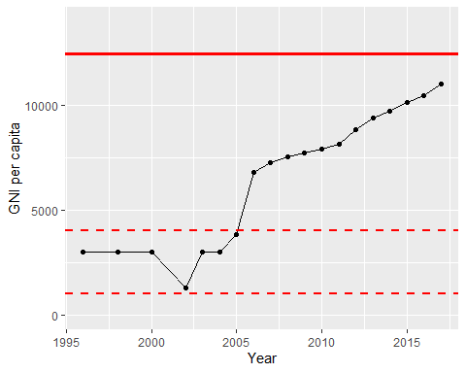

GNI Per Capita Trend